Tue, May 12, 2009 3:35:44 PM
Re: Nickname?
From: | David Clemons <dclemonsaz@yahoo.com>  View Contact
To: | "claunels@juno.com" <claunels@juno.com>
4 Files View Slideshow Download All
Back of Claudy in Car.jpg (119KB); Back of Claudy, Carl & Dad1.jpg (110KB); Claudy Carl & Dad1.jpg (180KB); Claudy in Car1.jpg (171KB)

On the back of some of these pics (attached), your mom writes/calls you "Babe"...I think they are the pics that were sent to my father when he was in the service...
dave
--- On Tue, 5/12/09, claunels@juno.com <claunels@juno.com> wrote:
From: claunels@juno.com <claunels@juno.com>
Subject: Re: Nickname?
To: dclemonsaz@yahoo.com
Date: Tuesday, May 12, 2009, 3:11 PM
Babe???? No....never. It's alway been Claudy. I can hear my dad saying "Cwaudy", though. Neat pix. I've seen similar, but not the same. Maybe all pix from those days resemble each other....know what I mean? I've saved them to my computer. Now if I could only figure out how to save them to disc.
C
____________________________________________________________
Aching back? Sore neck? Cick to learn how to manage your pain.

4 Images | View Slideshow | Download Selected | Download All
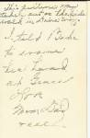 | 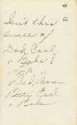 | 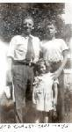
Back of Claudy in Car.jpg  (119KB) | Back of Claudy, Carl & Dad1.jpg  (110KB) | Claudy Carl & Dad1.jpg  (180KB)
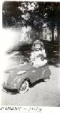
Claudy in Car1.jpg
(171KB)

