Certificate Vignette
Beautiful certificate from the Flint Motor Car Company issued October 17, 1923 to Vera Terry for 5 shares @ $15.00 per share. It is noted that the shares are to be acquired by installment payment, with shares not to be sold before October 1, 1925.
This historic document was printed by E.A. Wright Banknote Company and has an ornate border around it with a vignette of two allegorical women next to the Flint Logo. This item has the signatures of the Company's officers and is over 82 years old.
The Flint was an automobile marque that was assembled by the Flint Motors Division, Flint, Michigan between 1923 and 1927. Flint Motors was a wholly owned subsidiary of Durant Motors Company (USA).
The Flint was considered an assembled car because Durant Motors used components manufactured by outside suppliers to build its automobile lines. The cars were powered by a 6 cylinder Continental engine, and its body stampings were made by Budd in Philadelphia.
The origins of the Flint can be traced back to the Willys car company, which had been working on a prototype for a proposed 6-cylinder car. Willys had to sell off this prototype as part of its efforts to raise cash during a financial crisis. Once acquired, this prototype was further modified to create the Flint.
Following financial troubles at Durant Motors, the Flint was discontinued in 1927. The Flint was priced to compete with Buick, which was also assembled in Flint, Michigan.
History from Wikipedia and OldCompanyResearch.com (old stock certificate research)
-------------------------------------------------------------------------------------------------------------------------------------------
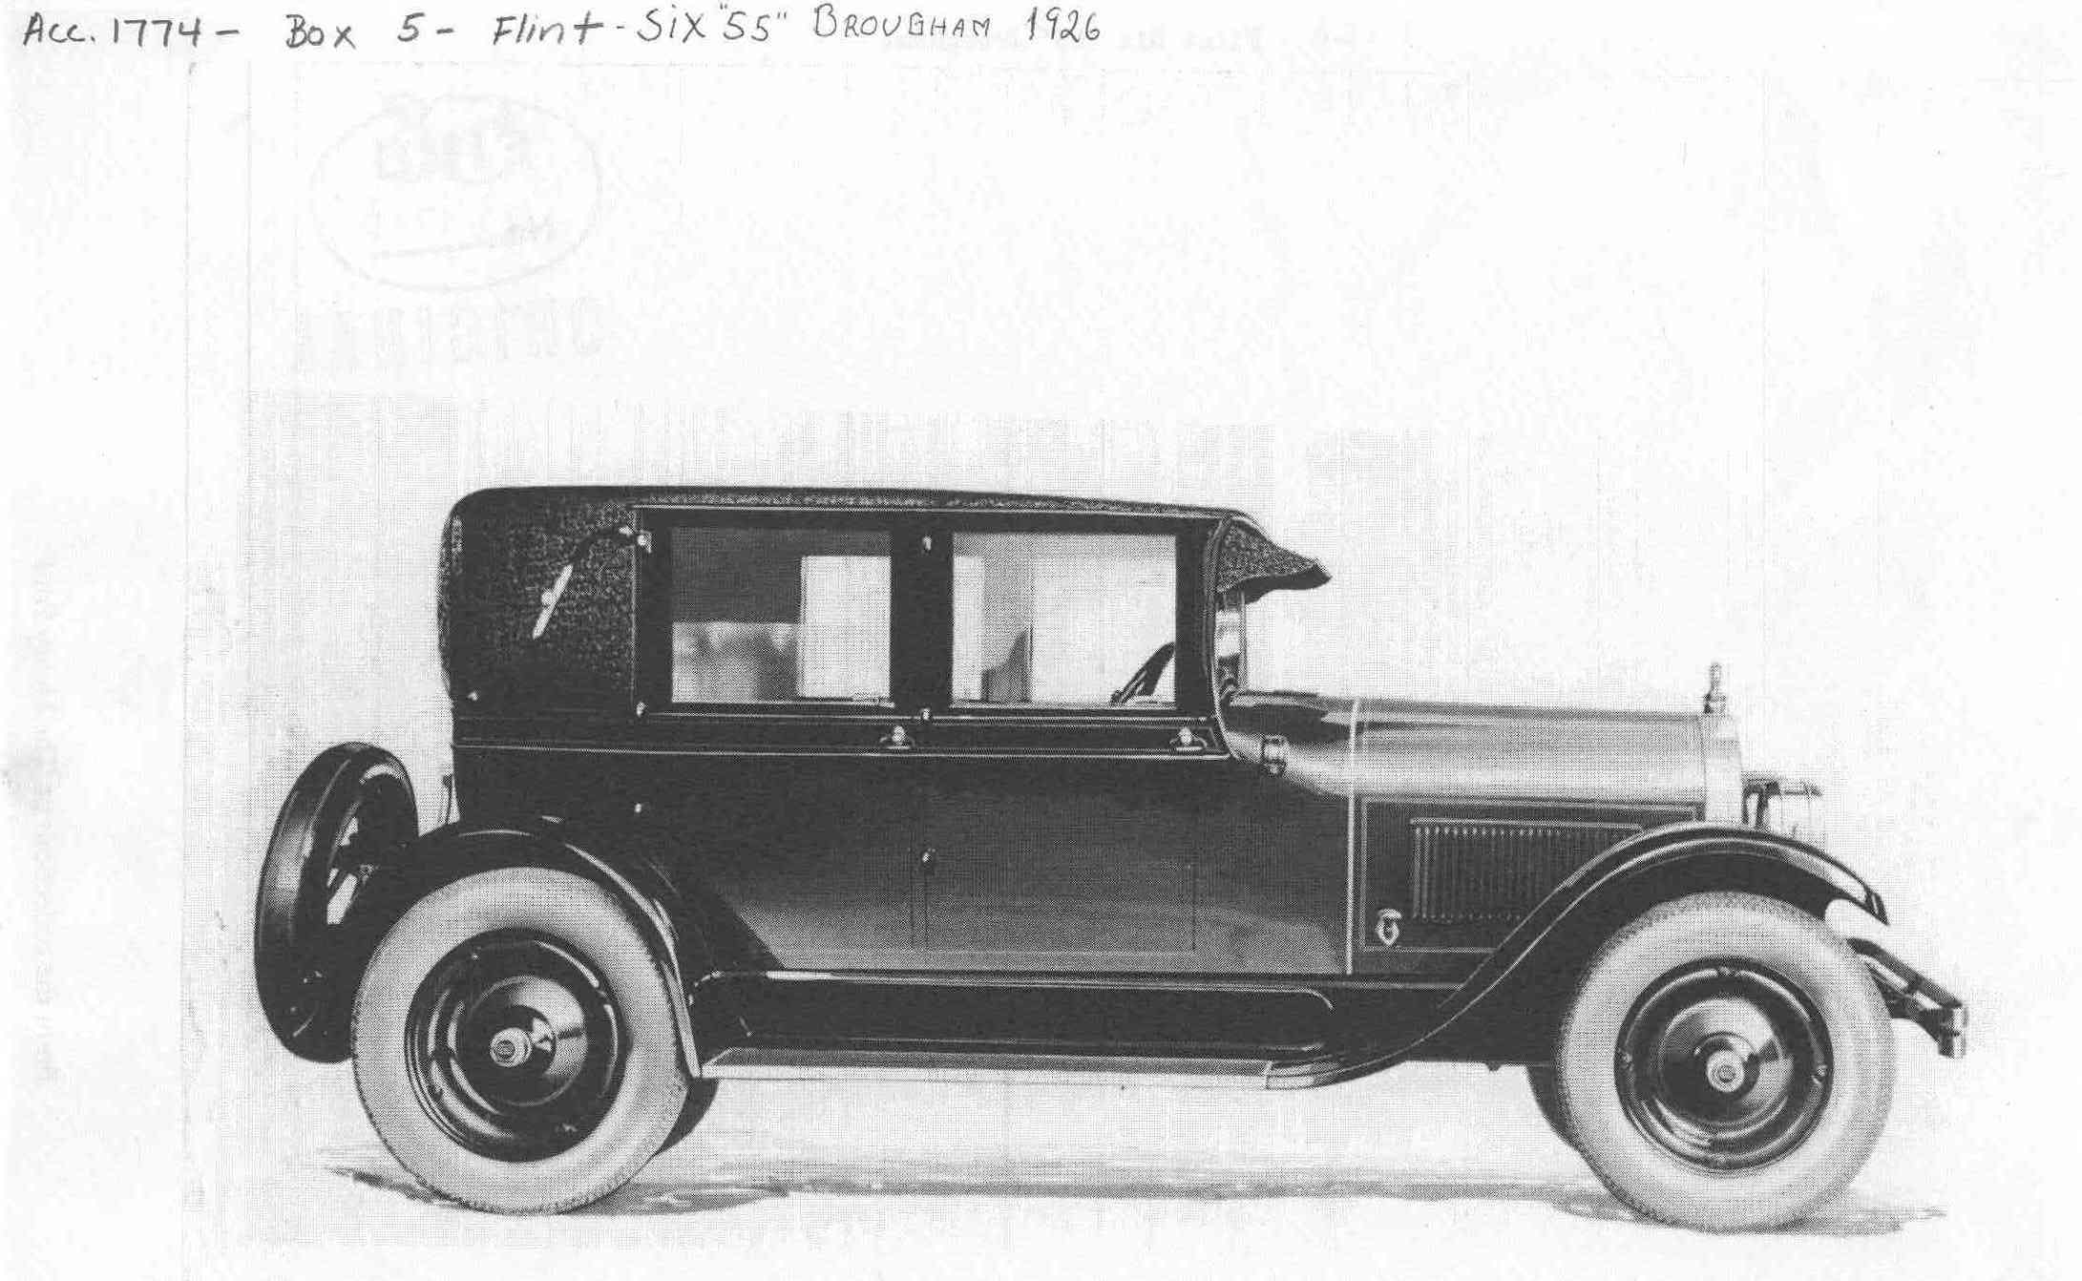
Flint Motor Co.
1922-1929
The Flint Motor Co. began as a division of Durant Motors by William Crapo Durant. Around 1922, Durant was forced to resign as president of General Motors. In an attempt to maintain General Motors' worth, he bought most of the General Motors stock to prevent bankruptcy. Durant then purchased 100 acres on South Saginaw Street to build the "Flint Six" cars which included sedans, roadsters and touring cars. (The picture above is of a Five-Passenger "60" Touring Car). The 1.5 million square foot building, the largest of its kind in the world at that time, was finally completed in October of 1923; however, the first car was manufactured the first of October. In the first eight months of operation, the value of the company rose from the initial $5 million to an estimated $18 million. By 1926, the building proved to be too large for manufacturing operations. The same year General Motors purchased the plant for $4 million and became the largest of the Fisher Body plants. After the sale of his building, Durant moved the Flint Motor Co. to Elizabeth, New Jersey in an attempt to bolster his failing Durant Motor Company. The depression of 1929 completely wiped out the last traces of Durant's companies. As a result, Durant lost $40 million.

